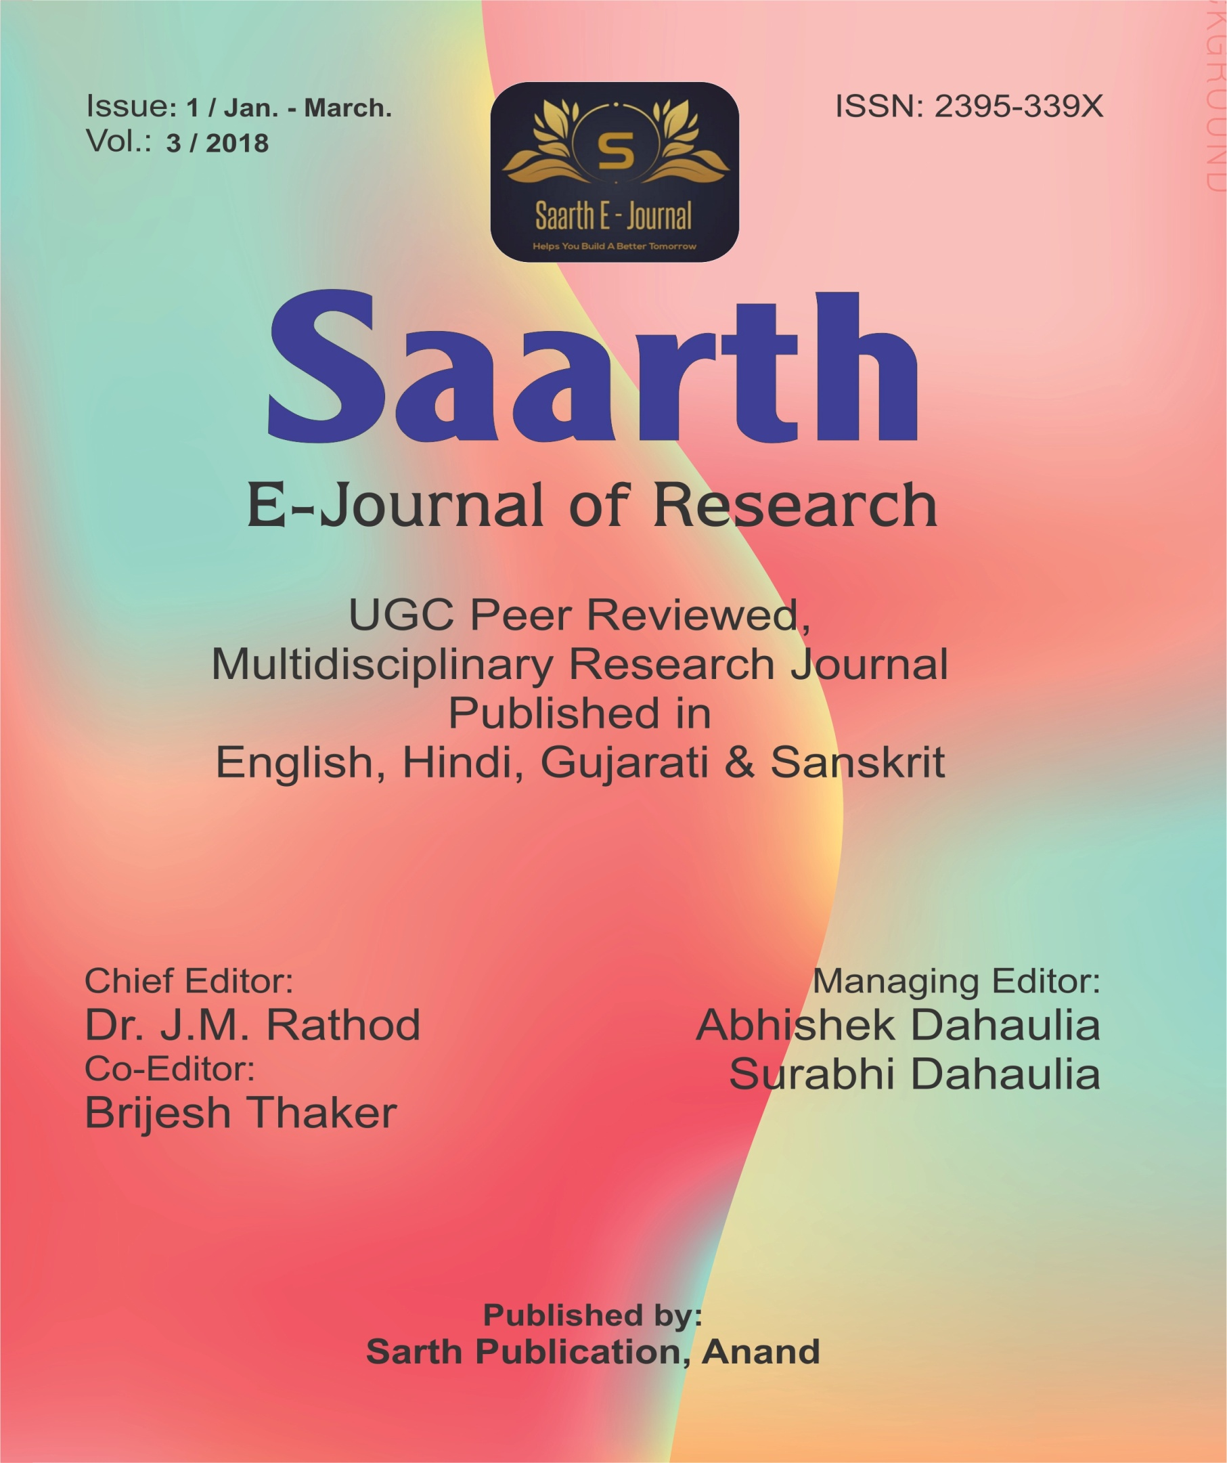

2018 contents / Jan To March
Sr.no | DOI No | Issue | Content | Author name
1 | 3/1/2018 | 1 | The princely State Gondal and British management | Mukesh D. Patel
2 | 3/1/2018 | 1 | What is Globalization? | Mukesh D. Patel
3 | 3/1/2018 | 1 | CHARLES DICKENS – HARD TIMES: AS A SOCIAL NOVEL | Dr. I. G. Purohit
4 | 3/1/2018 | 1 | Early Vedic Age : Origin, Social Life, Economic Life, Culture and Religion | Lalit Patel
5 | 3/1/2018 | 1 | Environmental Issues | Dr.Vinay N. Patel
6 | 3/1/2018 | 1 | જી.એસ.ટીનીવિવિધ ક્ષેત્રો પરઅસર | DR.VAISHALI. B. PATEL
7 | 3/1/2018 | 1 | “VAYU PURANA” IN THE CONTEXT OF ENVIRONMENT | Dr. Suhasben Jhala
8 | 3/1/2018 | 1 | ENVIRONMENT PROVISIONS UNDER CONSTITUTIONS OF INDIA | Dr.BinalbenSanjaykumarPatel
9 | 3/1/2018 | 1 | “A STUDY ON ENVIRONMENTAL PROBLEMS AND ,REMEDIES IN INDIA” | Mr. Yogeshkumar J. Mistry
10 | 3/1/2018 | 1 | Ecology in Wordsworth’s Poetry | Ms.Binita Vijay Gheewala
11 | 3/1/2018 | 1 | A COMPARATIVE STUDY OF THE THEME OF EDUCATION IN HIND SWARAJ AND IGNITED MINDS | Dr.Firoz Shaikh
12 | 3/1/2018 | 1 | INDIAN ACCOUNTING VS INTERNATIONAL ACCOUNTING | Dr. Harish M. Shah
13 | 3/1/2018 | 1 | ભારતમાં આર્થિક વિકાસના એક પરિબળ તરીકે વિદેશી પ્રત્યક્ષ મૂડીરોકાણ | ડો. અરવિંદ કે. પટેલ
 |  |  | BHARAT ME KANUNI SANSTHA AE AEVAM MAHILA AE KE ADHIKAR AEK ADHYYAN | Dr. Kalpana Niranjan
 |  |  | BHARAT ME KHADHANNA SURKSHA AEVAM SARVAJANIK VITARAN PRANALI | Dr. Majusha Shreevast vastav

